# UAT INITIATION &DESIGN

|  |  |
| --- | --- |
| Team ID | PNT2022TMID06779 |
| Project Name | A Novel Method for Digit Recognition System |
| Maximum Marks | 4 marks |

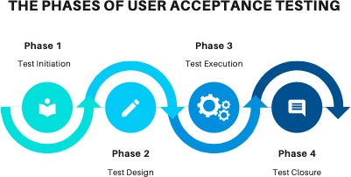

**UAT TEST INITIATION:**

* UAT test approach is defined
* Business users who would be performing this testing are identified
* Environments are sorted out
* Test data requirements are identified
* Required support from all other teams are discussed and support team identified

# UAT TEST DESIGN

* Business sceanrious to be validated are identified and document
* Relevant test data is identified
* Appropriate user accesses are requested and out

# UAT TEST EXECUTION

* + Test execution of the business scenarios are prefrimed
  + Appropriate defects are raised in the management tool
  + Defect re-testing and regression testing is performed

# UAT TEST CLOSURE

* + - UAT clouser report is produced
    - GO/NO-GO decision is discussed and recommended